Chapter 5: Born of the Black Sea - The Indo-European Invasions
Most modern day Whites are to the greatest part, either direct or part descendants of a great wave of White peoples who swept into Europe from about 5000 BC till around 500 BC - these peoples, Nordic in terms of the White racial sub-groupings, had their original heartland in the region known today as central and southern Russia (hence Whites are often today called Caucasians - after the Caucasus mountains which are situated in the southern reaches of that country).
It is still unknown precisely what caused these Indo-European peoples to start migrating. Recent research indicates that the flooding of the Black Sea Basin from the Mediterranean - established as a factual occurrence around 5600 BC - was the probable cause of the first great movements, and the time scale would certainly fit.
Meltwaters from the retreating ice sheets at the end of the Pleistocene caused the world's oceans to rise by almost 100 meters. In 5600 BC, the rising waters of the Mediterranean Sea burst through the narrow neck of the Bosporus, inundating and destroying the civilization ringing the fertile Black Sea Basin. It is this catastrophe which triggered the great Indo-European migrations and spawned the Biblical legend of the flood, familiar to adherents of the Christian faith.
With the aid of the horse, the first Indo-Europeans moved in all directions, disrupting the slow but steady pace of development everywhere they went. Large numbers settled in northern Europe, staying there till they later began again to move south; others moved off to the Middle and Near East, while others ventured west, crossing into Britain and Spain.
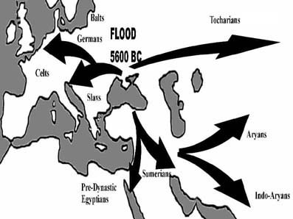
Leaving the Black Sea Basin, the Nordic Indo-European peoples invaded Europe and Asia. Europe was settled by four main groups: the Celts, the Germans, the Balts and the Slavs. In the south they settled pre-dynastic Egypt and the Middle East, penetrating India (the Indo-Aryans); Afghanistan (the Aryans); and China - see chapter six. The difference between the western and eastern migrations of the Indo-Europeans was that in the west they mixed with genetically similar populations - while in the east they mixed with, and were eventually submerged by, genetically dissimilar peoples.
NORDIC "BATTLE AXE PEOPLE" - THEIR IRON-MAKING ADVANTAGE
These Nordics slowly crept westward, invading and re-invading western Europe for a period of nearly 6000 years, finally resulting in the establishment of a new Nordic heartland in northern Europe.
Their great advantage over the already existing White Mediterranean and Proto-Nordic populations was that they brought with them the secret of iron working: this is why some became known as the "battle axe people".
From this heartland in northern Europe - the womb of nations (vagina gentium, as the Romans called the region) successive waves of Indo-European Nordic invaders swept down over a period of centuries into all parts of Europe and into the Near East, conquering or displacing the peoples they found.
These original Nordic tribes had stone buildings and worked bronze and copper. How much of this metal working skill was passed south to the Middle Eastern civilizations remains a matter of debate.
However, what is certain is that successive waves of Nordic tribes started invading central and southern Europe in earnest about 2000 BC, and caused the Old European civilizations to topple. Nordic tribes occupied large regions of Turkey, Crete, Greece and southern Europe and Italy.
The invading Nordics soon integrated with the largely Mediterranean populations of these areas and in many cases provided the leadership elite of these territories.
Some Nordic tribes migrated into the Far East - as far as China, where Nordic remains have been found in burial chambers. The Indo-European Nordic tribes were responsible for many of the world's principal civilizations: the Aryans in India, the Kassites, the Hittites, Persian, Mycenaean, Greek, Roman, Celtic, Teutonic, Slavic and latter day Western European cultures.
THE INDO-EUROPEAN INVASIONS - PART ONE
EUROPE
The largest Indo-European invasion of Europe was carried out by four main groups:
- The Celts;
- The Germans;
- The Balts; and
- The Slavs.
All of these four major groupings arrived in the European continent in waves from around 4000 BC up to as late as 500 BC.
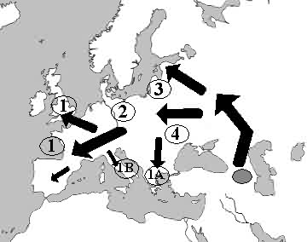
Above: The great Nordic Indo-European invasions of Europe took place in four main waves, and then in a number of sub-waves. Each sub-wave was a smaller tribe from one of the four major migrations. Leaving their ancestral homeland in the Caucasus, the Celts (1); the Germans (2), the Balts (3) and the Slavs (4) settled different regions of Europe, often giving their names to those regions. Sub-waves of note included the Mycenae (1A) into Greece and the Latini (1B) into Italy - both of these sparked off the great Classical civilizations for which those lands became famous. In all of these regions, the invaders found the already present population of Old Europeans to be largely racially assimilable. Hence the Latini mixed with the Etruscans in Italy, producing a Nordic/Mediterranean mix which typified the original Roman type. The same process occurred in Ireland, which is the cause of the "Irish look" varying between Nordic (blue eyed and blonde) and dark hair and dark eyes, or dark hair and light eyes.
The word Celt itself derived from the word Keltoi, the name given to the invaders by the Greek writer Herodotus. To the Romans, the Celts were known as Galli, or Gauls; and in British Isles as Britanni.
Celtic tribes invaded Greece and Italy. In 390 BC Celts sacked Rome itself, and followed this up with a raid on the holy Greek site of Delphi in 279 BC.
Although these Indo-European tribes used different names, they were all of common Nordic sub-racial stock. Their languages all stemmed from a single proto-Indo-European language, which formed at a time when all of their ancestors lived together in their original Indo-European heartland in modern day Russia.
The influx of a relatively large amount of new Nordic sub-groupings into Europe affected the racial make-up of the various regions in different ways, depending upon the nature of the already existing original European population living there.
In areas where there was a sparse population, or where there was a greater degree of Proto-Nordics living, the Indo-Europeans maintained to a greater degree their Nordic characteristics.
Where there was an already existing Proto-Nordic/Alpine/Mediterranean mix, the nordicism of the new arrivals was soon diluted. The least populated areas and the least Alpine/Mediterranean peoples were in northern and western Europe, and these areas became a new Nordic heartland, a situation which has remained unaltered until very recently.
BRITAIN NAMED AFTER BRITANNI CELTS
By 600 BC, the Britanni Celts had occupied much of what is today known as western Europe - France, parts of the Low Countries (Belgium, Holland), Britain and Spain. The very names Brittany (in France) and Britain itself are derived from this group.
These Celts migrating westward found the regions relatively sparsely populated with an already quite mixed Proto-Nordic/Alpine/Mediterranean peoples. In most parts the Celts mixed easily with these groupings, producing a wide range of sub-grouping racial types. This has led to the Celtic "look" varying between the typical short, brown-eyed and haired "Celtic" Welshman; and the red-haired blue-eyed Scotsman also being a called a "Celt."
These western European Celts were later to be overrun by the descendants of other Indo-European tribes who had invaded Italy and had become the Romans.
THE GERMANS AND BALTS IN CENTRAL AND NORTHERN EUROPE
The Germani Indo-European tribes initially settled in what is today Denmark and southern Scandinavia around the year 4000 BC, but soon thereafter starting moving south, closer to central Europe, later giving their name to Germany.
The Balts occupied the northern coast of the continent (giving their name to the Baltic sea) and the Scandinavian countries (dominating them, with the notable exception of Finland, which has to this day retained a large part of its original Alpine/Mediterranean population make-up).
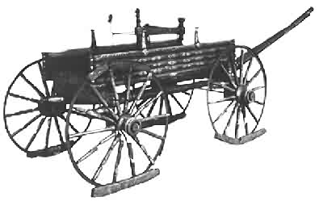 | 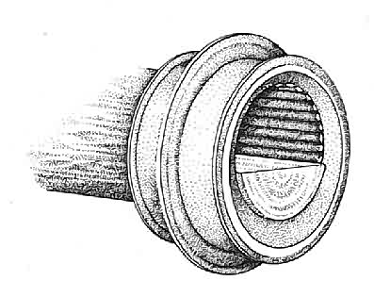
Above: A wagon which summarizes the technical sophistication of pre-Roman Germans: The Dejbjerg wagon from Denmark, circa 500 BC, includes an astonishingly sophisticated roller bearing system of wooden pins in a bronze brace, to facilitate the turning of the wheel on its axle. Such sophisticated technology shows that the pre-Roman Empire Celts, Germans, Balts and Slavs were actually not "barbarians" at all but highly developed people capable of stunning technological feats. (National Museum, Copenhagen).
From 1800 to 400 BC, Celts in southern Germany and Austria developed two advanced metalworking cultures, named by archaeologists after the places where the most plentiful artifacts were found: Urnfield and Hallstatt in Upper Austria. The skills developed in each of these two spread throughout Europe - they introduced the use of iron for tools and weapons.
In Central Europe the Germans also established themselves in a wide belt running from eastern France through to Poland and south into the Balkans. It is presumed that advance parties of Germans could also have been responsible for the wave of Indo-European peoples called the Latini, who penetrated Italy around this time.
THE CELTS INVADE SOUTHERN EUROPE
A tribe of Indo-Europeans called the Latini penetrated as far south as Italy, taking control of that peninsula and mixing with the existing original European populations in Italy, and creating what was later to become the world's greatest empire - Rome. The Latini gave their name to the language they carried with them, Latin. In an act of irony, Roman military power was to later overwhelm their distant Indo-European cousins, the Celts in France and Britain, but was in turn to be overrun by the descendants of the Indo-European Germans.
The Latini were not the only Celts to move down the Italian peninsula. Around 400 BC yet another tribe of Celts invaded Northern Italy, drove out an Etruscan settlement and founded the city of Milan. In 390 BC, a Celtic army even succeeded in invading the city of Rome itself, and only left once the Romans had paid them a ransom in gold.
In southern France and Spain the Celts met and mixed with a well established Mediterranean population, losing much of their original Nordic physiology because of the far greater number of Mediterraneans present in that region. Many of these Celtic/Mediterranean peoples in Spain were later to be occupied by Arabic Islamic armies during the first thousand years AD. Intermingling with the Arabic conquerors produced many people in Spain who are actually Celtic/Mediterranean/Arabic mixes, displaying none of the physical characteristics of their original Indo-European ancestors.
There are however still many examples of original Celtic and Mediterranean peoples in Spain to this day, even if they are declining in number.
MYCENAE - THE FIRST INDO-EUROPEAN INVADERS IN SOUTH EASTERN EUROPE
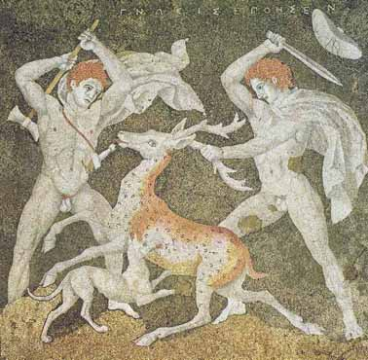
Above: The influence of Indo-European Nordic racial types (even the pubic hair of the figures is blond colored) on the Balkans is clear from this floor mosaic at the Macedonian capital of Pella, just north west of Salonika in northern Greece, circa 4th Century BC.
The Greek mainland, which was occupied by original Old European Mediterranean types, fell before an invasion of Indo-Europeans called the Mycenae - this tribe were the first to establish the basis upon which the classical Grecian age was to built, albeit only after yet another wave of Nordic invaders.
The Mycenae arose on a part of the Greek mainland known as the Peloponnesus, around 1900 BC with the sudden appearance of migratory Nordic tribes who quickly absorbed the local population. There is evidence that the Mycenae had contact with yet another invading Indo-European tribe, the Hittites, as evidence of trading activity exists between these two peoples.
On the Greek mainland, many towns started emerging at this time, and Mycenaean colonies were established on the coast of Turkey and even as far as Syria. Mycenaeans are regarded as the forerunners of the classic Greek civilization and they left a magnificent city at Mycenae, whose most famous inhabitant was the king Agamemnon.
Mycenae was sacked and destroyed in 1100 BC by an invasion of yet another Nordic tribe, the Dorics. The descendants of the Dorics were known as the Spartans and the Corinthians, two peoples later to feature dramatically in Greek history. The destruction of Mycenae caused many Mycenaeans to flee the Peloponnesus, and a sizable number went to the east cost of today's Turkey.
This coastal settlement became known as Ionia, and the Ionian civilization retained the rich legacy of Mycenae and also added elements of Lydian culture. The civilization that was later to rise to great heights in Athens, was born in Ionia.
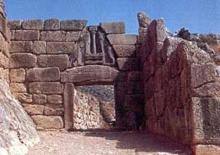
Above: The Lion Gate at Mycenae, circa 1,500 BC.
THE DORICS - FOUNDERS OF GREECE 1100 BC
Starting about 1100 BC, a new wave of Indo-European Nordics invaded Greece from the north: the Dorics. The period from the time of the Dorian invasion (1100 BC) to about 750 BC, is known for the introduction of iron working to the Grecian peninsula. The time of the Dorian Age is known to historians as the Homeric Age, because little is known about it except from the writings of the poet Homer, in his epic poems the Iliad and the Odyssey.
SOCIAL STRUCTURE OF THE DORICS
Homeric age man was apparently warlike, brave and desirous of hardship. By all accounts it seems that Homeric man had all of these three attributes in abundance.
The economies of the time were essentially subsistence agricultural systems with a government made up of tribal kings and advisors drawn from important noble families.
It was at about this time that the city state, or polis, was started. Each city had an elevated fortified site, known as its acropolis - where the city's important inhabitants could take refuge or gather to worship their gods.
In time the place directly below the acropolis developed a residential and trading area known as the asty. The asty and the acropolis combined under one central jurisdictive rule, and this unit became known as the polis. The very word politics is derived from this Greek word, polis.
THE SLAVS - FROM THE CAULDRON OF CONFLICT
Of all the Indo-European peoples who settled in Europe around 2000 BC - during the great Nordic invasions, a group which became known as the Slavs settled the closest to the ancestral homelands in southern Russia.
The land they settled - today known as the Ukraine and Byelorussia ("White" Russia) - was ideal for cereal farming and this encouraged the settlers to turn to agriculture rather than war or conquest. By 1000 BC, these Indo-European forerunners of the Slavs had started to move westward, occupying territory around the Vistula River, in present day Poland.
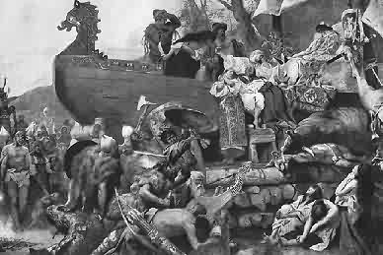
Above: This somewhat idealized painting is of a Slav funeral pyre for one of their chieftains around the year 900AD. In common with many Indo-Europeans, the Slavs traditionally cremated their important dead . Where burial was chosen over cremation, it was also common to bury all the chief 's artifacts with the corpse. This painting was made based on a description provided by a visitor to southern Russia at the time, and it is significant that the account had a Viking style boat in the picture - a sure indication that the original Slavs were of virtually identical racial and cultural stock to the Indo-Europeans who settled in Scandinavia and who became Vikings.
Around 700 BC, the whole region was conquered by yet another Indo-European tribe, the Scythians, who appeared from the south (where another branch of that tribe had penetrated into Asia Minor and the Near East).
By 200 BC, the Scythians had mastered much of the area, easily outfighting the agricultural Slavic farmers. However by 100 BC another - one of the last - Indo-European invaders, a tribe called the Sarmatians, had replaced the Scythians as masters of the Slavic lands, and the last of the Scythian peoples were absorbed into the new Indo-European conquerors, the two groups being racially virtually identical.
In 600 BC, another tribe of Indo-Europeans, the Goths swept down from Northern Europe and conquered the Sarmatians, taking possession of the lands in eastern Europe.
This repeated conquering and reconquering by peoples who all essentially were of the same stock - Indo-European - created the mix known as the Slavs.
Originally then, the Slavs were a virtually pure Indo-European people, and only later were certain elements of the Slavic population to the very east mixed to a small degree with remnants of Mongolian conquerors, creating a number of mixed race Slavic/Mongolian peoples, who quite incorrectly have become to be regarded as "typically Slavic".
Probably because of their proximity to the ancient homeland in southern Russia, the tribes who eventually formed the Slavs retained the cultural traits of their ancestors the longest.
The Indo-European sun worship religion persisted right into the 12th Century amongst the Slavs, and principle amongst their gods was a hammer wielding deity who rode in a chariot - obviously sharing a common mythological ancestry with the Scandinavian god, Thor.
As the Roman Empire began to unravel at the seams, the Slavs started moving westwards, first penetrating into the Balkan peninsula and then into central Europe.
By 650 AD the Slavs had seized the coastline along the Adriatic Sea opposite Italy (today's Albania). They also later penetrated as far south as Turkey, where these elements were swallowed up into the larger mixed race mass occupying that country by that stage in history.
The Slavs in eastern Europe not only bore the brunt of the Mongolian Hunnish invasion of Europe, but also were occupied for well on 1000 years by the Muslim Turks.
The limited mixing that took place with parts of both these conquerors created the dark "Slavic" look associated with many in the region today. Many of these racial types are the result of these mixtures, although there are still of course large numbers of Slavs who show the physical characteristics of their Indo-European ancestors.
CELTIC INNOVATIONS - CHAIN MAIL AND SOAP
These Indo-European tribes may have had a common root, but this did not stop them fighting with each other as much as with anybody else, with each tribe being headed by a king and further divided by class into Druids (priests), warrior nobles, and commoners.
The Roman conquest of south eastern Europe, France and Britain effectively destroyed the Celtic heritage. The Celts were not as literate as the Romans and thus had less of the organizational skills or abilities of their conquerors.
However, the Celts were the inventors of chain link armor, iron horse shoes and were the first to make seamless iron tires for their chariots. Another important Celtic innovation was soap.
In their art forms, the intricacy of which has become legendary, the links the Celts had with other Indo-European tribes is revealed. The Celtic style is marked by a preference for stylized plant motifs, usually of Greek origin, and fantastic animals, derived from the Scythians and other Russian steppe Indo-Europeans. Other favorite designs are elliptical curves and opposing curves, spirals, and chevrons, also derived from Russian steppe art.
Almost all of the original Indo-Europeans worshipped the sun, and the sun wheel image - a circle with a cross through it, dominated many designs. The modern Celtic Cross, regarded today as a Christian symbol, has been directly copied from this original Indo-European root and is originally a very pagan symbol.
Today, Celtic as a language, has survived at only the extreme ends of the area occupied by the Celts - Wales, Scotland and a few areas in Ireland.
Chapter 5: Born of the Black Sea - The Indo-European Invasions
PART II - THE ORIGINAL EUROPEAN RELIGION
When reviewing the Indo-European gods, or as they became, the northern European gods, it becomes obvious just how deeply rooted these gods and beliefs are amongst the White peoples to this very day.
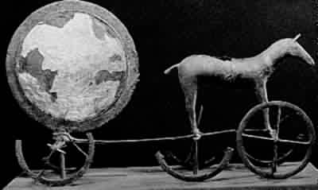
Above: An ancient German religious ceremonial chariot, with bronze and gold worked disc and horse, circa 1,400 BC. Found in the Trundholm Bog on the Danish island of Seeland.
Very many of the original Indo-European gods' names were either taken over by Christianity (Hel, the name of the goddess of the underworld was, for example, plagiarized directly by Christianity) or were kept in various forms, so that even five of the seven days of the modern week are named after them, as detailed below.
That this is so should not be surprising: these gods were the main religion of the White people of Europe for at least six thousand years, compared to the less than one thousand years that Christianity has existed in northern Europe to date.
The chief characteristics of this original White religion and its array of gods were:
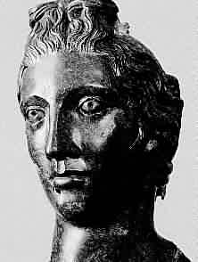
Above: Bronze head of the Celtic Goddess, Rosmetra, wife of Mercury. German sculpture, circa 250 BC.
- The world itself was the product of the great world-tree, Yggdrasil, which reached through all time and space. Yggdrasil was however always under attack from an evil serpent, Nidhogg. The fountain of Mimir, source of hidden wisdom, lay under one of the roots of the tree;
- Worship of any of these gods was usually conducted in the open - often near holy trees or within arrangements of stones, with the Indo-Europeans using and building even more megalith sites in Europe for this purpose;
- Odin (also known Odhinn; called Woden by the Anglo-Saxons and Wodan or Woutan by the Germans) was the king of the gods. His two black ravens, Huginn ("Thought") and Muninn ("Memory"), flew all over the world to report on the doings of men and gods alike;
- Odin's court was in the great citadel of Valhalla, where all brave warriors went after dying in battle. When Odin himself took to travel he used his eight-footed steed, Sleipner; armed himself with his spear, Gungnir, and his most precious jewel, the ring called Draupner;
- Odin was also the god of wisdom, poetry, and magic, and he sacrificed an eye for the privilege of drinking from Mimir, the fountain of wisdom. Odin had three wives;
- Thor was the eldest son of Odin and the strongest of the gods. He had a magic hammer, which he threw with the aid of iron gloves and which always returned to him;
- Odin's other son was Balder (or Baldur), the god of light and joy, was killed after the evil god Loki tricked Baldur's blind twin brother, Hoder, the god of darkness, into killing him; Baldur was god of the sun;
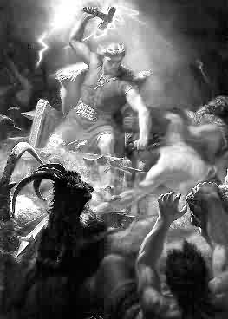
Above: Thor, son of Odin, striking down enemies with his mighty hammer, Mjollnir. This picture, painted in 1872, shows Thor riding in a chariot drawn by goats.
- Frei or Freyr was the son of the fertility god Njord. Freyr was the god of fruitfulness, prosperity, and peace and the bestower of sunlight and rain. He wakened the earth from the long sleep of winter, and prayers for a bountiful harvest were addressed to him. Frey was the patron god of Sweden; his chief shrine was at Uppsala. His sister was Freya;
- Freya or Freyja was the goddess of love, fertility, and beauty, sometimes identified as the goddess of battle and death. Blond, blue-eyed, and beautiful, Freya traveled on a golden-bristled boar or in a chariot drawn by cats. In Germany, Freya was sometimes identified with Frigg, the wife of Odin;
- Frigg or Frigga, was the goddess of the sky and wife of Odin, the chief of the gods. She was worshipped as the protector of married love and housewives. A bunch of keys was her symbol;
- Tiu was the god of war and battles. He is represented as having only one hand, with some stories having it because he can only give victory to one side, or because it was bitten off by the wolf Fernis;
- Hel was the goddess of the dead. She dwelt beneath one of the three roots of the sacred ash tree Yggdrasil and was the daughter of Loki, the spirit of mischief or evil. Odin condemned Hel into the underworld and placed her in charge there, never to emerge again;
- Loki was a giant who represented evil and was possessed of great knowledge and cunning. Loki and Hel, goddess of the underworld, would lead the forces of evil against the gods, in the final battle between good and evil, the "Ragnarok", or end of the days;
- Besides these major deities, there were a number of other lesser gods who were just as popular from time to time: Hermod, Bragi, and Forseti; Idun, Nanna, and Sif;
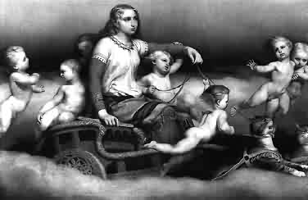
Above: Freyja, the Indo-European Goddess of love and beauty, riding her chariot drawn by cats. A 19th Century painting.
- The Valkyries were a band of warrior-maidens who were sometimes portrayed as Odin's own daughters, they included Brunhilde (later to become a central character in a Wagner opera). The Valkyries helped Odin choose which warriors deserved to go to Valhalla after dying in battle. At Valhalla, the warriors would spend their time fighting or feasting until "Ragnarok."
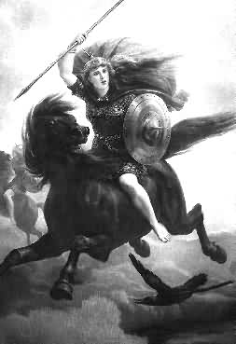
Above: Warrior maidens, sometimes regarded as the daughters of Odin, the Valkyries carried the bodies of slain warriors to Valhalla and there waited upon them in an eternal banquet.

FIVE DAYS OF THE WEEK NAMED AFTER THE NORTHERN GODS
Tuesday is named after Tiu, the god of war; - this day is still called Tisdag in Sweden and Tirsdag in Denmark. Wednesday is named after Wodan, or Wotan / Odin himself (Wodansday). In Sweden and Denmark, the day is called Onsdag.
Thursday is directly named after Thor's name (Thorsday), while his mother, Frigg, is remembered in the day called Friday (Frigg's day). Baldur, god of the sun and light, is remembered in Sunday.
While the name of the day "Saturday" is not derived from Northern Gods, it is however drawn from the equally pagan and equally Indo-European pre-Christian Roman celebration of Saturnalia. Only the day "Monday", or Day of the Moon, does not have an overtly pre-Christian origin.

Chapter 5: Born of the Black Sea - The Indo-European Invasions
PART V: THE HISTORY OF THE SWASTIKA
Few symbols are as well known in the world today as the swastika. While it is common perception that the swastika is a German Nazi Party symbol, it is in fact far older that the Nazi Party, and its origin lies in the Sanskrit language carried by the Indo-European peoples throughout their migrations.
THE SUN WHEEL AND SWASTIKA IN HISTORY
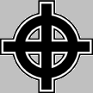
One of the symbols the Aryans had was the sun wheel, representing the sun and originally meaning "well being". Originally a letter of the ancient Indo-European Sanskrit language, this emblem was carried by Celts, Germans and Slavs throughout their wanderings, with the Celtic Cross later incorporated into Christian symbolism. The sun-wheel was developed into the sign known today as the swastika and incorporated into the Indo-Aryan's religion, from where it was transported over into the Hindu religion, which sprang from a corruption of the Indo-Aryans' beliefs. This is the reason why the swastika can be seen to this day in Hindu temples.
As an enduring symbol of the Indo-European peoples wherever they went, the swastika is found in all the lands where these people settled. Some examples:
1. The Swastika in India:
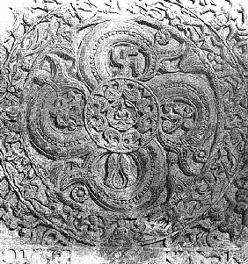
Above: The swastika can be seen on a carving called an ayagaptha, in Mathura, India. The emblem is one of the last remains of the tribe of Nordic Indo-Europeans - who called themselves Aryans - who invaded India. In that land, they were eventually absorbed into the overwhelming non-White mass, creating the caste system still present in that country to this day.
2. The Swastika in Classical Greece:
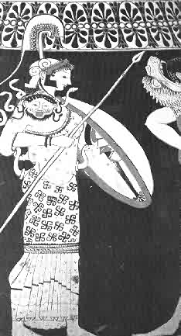
Above: An example of how the swastika was also used as a symbol in Classical Greece. Here it can be seen as a decoration on the clothing of a picture of Athene, the Goddess of Wisdom, the arts and war - and also patron of the city of Athens. This detail is from a Greek vase dating from approximately 500 BC.
3. The Swastika in Classical Rome:
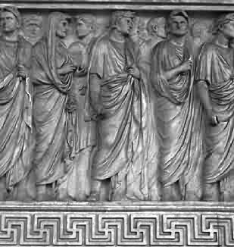
Above: The Indo-European origins of the Romans - in particular the Latini tribe - are apparent through their liberal use of the swastika as an emblem. Here the swastika can be seen upon the Ara Pacis Augustae: the altar built to commemorate the peace established by Augustus, consecrated 4 July 13 BC. The swastika can also be seen in a virtually identical format in many Classical Greek designs: hence it is often called a "Greek key" pattern.
4. The Swastika in the Viking era
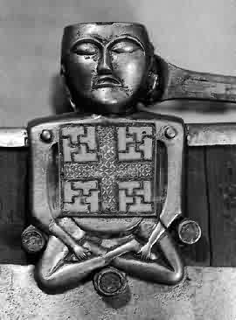
Above: The Indo-European origins of the Vikings is illustrated by this detail from a very well preserved Viking ship uncovered by archeologists in Scandinavia, known as the Osberg ship, circa 800 AD. A handle mount on a bucket found in the ship depicts a figure carrying a shield with four swastika sun emblems in its corners. The fact that the swastika appears as a symbol from Scandinavia to Italy to India indicates precisely how far the Indo-European influence was felt.
5. The Isle of Man Triskelion, ca. 10 Century AD.
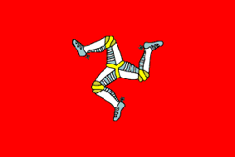
According to the islanders, this symbol was of Norsk [Norwegian] origin, and was displayed on the armorial bearings of the Kings of Norway.
The Triskelion also appears on this 6th Century B.C. Greek vase - further evidence of cultural links through race and time:
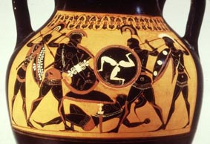
6. The Swastika and Adolf Hitler
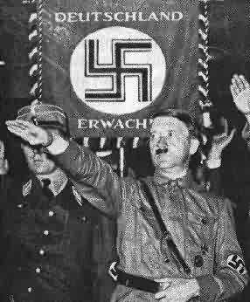
Above: The sun wheel, or swastika, was a symbol in the ancient Nordic Indo-European language, Sanskrit, meaning "well being" or "good", from the fact that the sun was regarded as a source of goodness. This symbol was carried by invading Indo-Europeans into Europe, India and even China. The ancient link to the Indo-European people was then the reason why Adolf Hitler chose the swastika as his movement's emblem, as pictured here.
7. The Swastika in Western Architecture
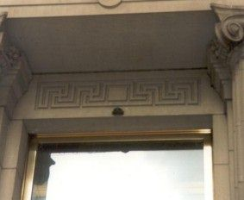
Prior to its demonizing through its association with Adolf Hitler, the swastika was a popular motif in much of western architecture, from the Opera Building in Paris through to the front door of the Metropolitan Museum of Art in New York. Far left: The entrance to the 'Met' and alongside, a close-up view of the swastika motif, prominently displayed over the heads of thousands of unsuspecting visitors.

